Vincent’s Favorite Meatballs by Breanna Sawatzky

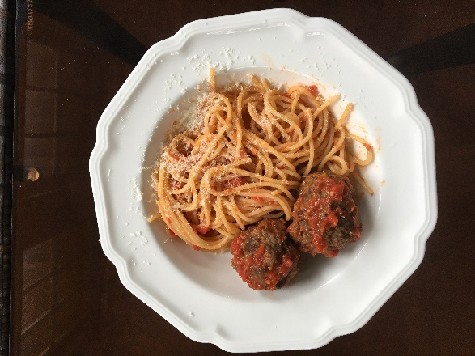
Ingredients:
1 lb lean ground beef (not extra lean)
¼ cup bread crumbs
¼ cup grated parmesan or pecorino romano cheese
1 egg, beaten
2 Tbsp parsley, finely chopped
1/3 cup warm milk
½ tsp sea salt
¼ tsp black pepper
2 Tbsp olive oil
500 ml marinara sauce (homemade or store bought)

Instructions:
- Preheat oven to 400 degrees F.

- Line baking sheet with parchment.

- In a medium sized bowl, with your hands, gently mix beef, bread crumbs, cheese, egg, parsley, milk, salt and pepper.

- Form into ten balls and place on lined baking sheet. Brush with olive oil.

- Roast in the oven for 20 minutes.

- Heat marinara in a pan over medium heat until simmering. Add meatballs and simmer 10 minutes.

- Serve with spaghetti and some more grated cheese.

