Tortellini SA Soup by Amanda Dorscheid
Ingredients
Olivieri rainbow cheese tortellini
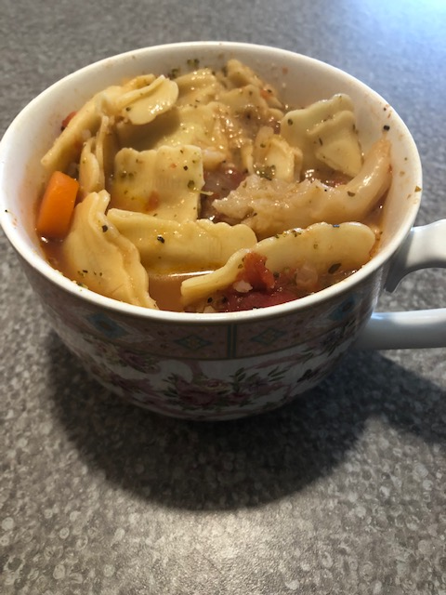
Chicken broth
Frozen California mixed veggies
Yellow onion
Garlic
Canned stewed tomatoes (I use the one with Italian seasoning)
Italian seasoning
Salt and pepper

Instructions
Cooked diced onion and garlic in oil
Add one carton of chicken broth, salt, pepper, Italian seasoning, and frozen veggies
Cook on high for 10 minutes
Add tortellini, stewed tomatoes, and more salt, pepper, and Italian seasoning to taste
Cook on medium for 20 minutes
This is the best soup for when you are sick or upset, the more pepper and garlic you add the more you sweat out your illness/anger/stress/etc!

