Sweet Easter Bread Recipe;
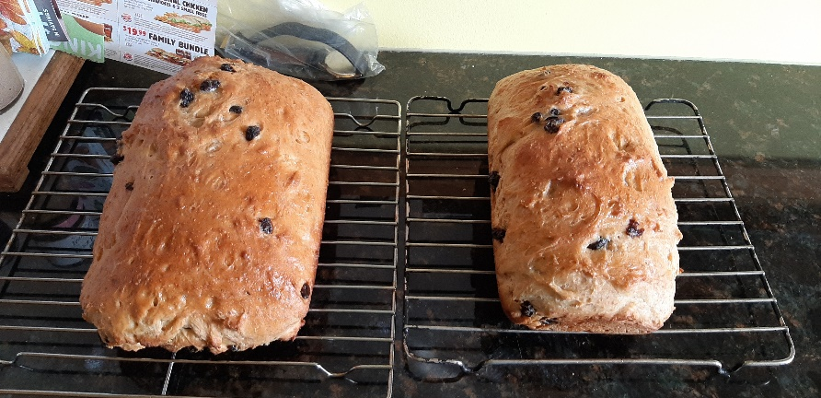
Ingredients:
½ cup raisins
2 ½ teaspoons yeast
¼ cup lukewarm water
1 cup scalded milk
¼ cup unsalted butter
1/3 cup sugar
1 teaspoon salt
1 egg
1 tablespoon orange zest
3 ½ cups all purpose flour

Directions:
- In small bowl, soak the raisins in warm water for about 20 minutes, or as long as it takes to make the dough. This ensures that they will be moist and delicious in the bread.
- In another small bowl, combine the yeast with the lukewarm water and let sit for a few minutes.
- In a large bowl, combine the hot scalded (not boiled) milk with the butter, sugar, and salt. Allow the butter to melt and the sugar and salt to dissolve in the hot milk. Cool the milk and butter mixture until it is lukewarm.
- Add the yeast mixture to the lukewarm milk mixture and stir to combine.
- Beat in the egg and orange zest.
- Place the mixture in the bowl of a stand mixer, put on low speed and slowly add in the flour. Mix until it is completely incorporated and a soft dough has formed.
- Strain the raisins and add them to the dough. Mix again until the raisins are fully incorporated into the dough.
- Cover the dough and allow to rise for 30 minutes, until the dough has about doubled.
- Grease two 9 x 5” loaf pans.
- Split the dough in half. Roll each half into a rectangle and place each in a prepared loaf pan.
- Cover the loaves with a towel and let rise for about 20 minutes.
- Preheat the oven to 350F.
- Bake the loaves for about 30 minutes, or until golden brown.

Serve warm with butter and jam….yum!

