ROS-JITO MOCKTAIL by Chantel Reles
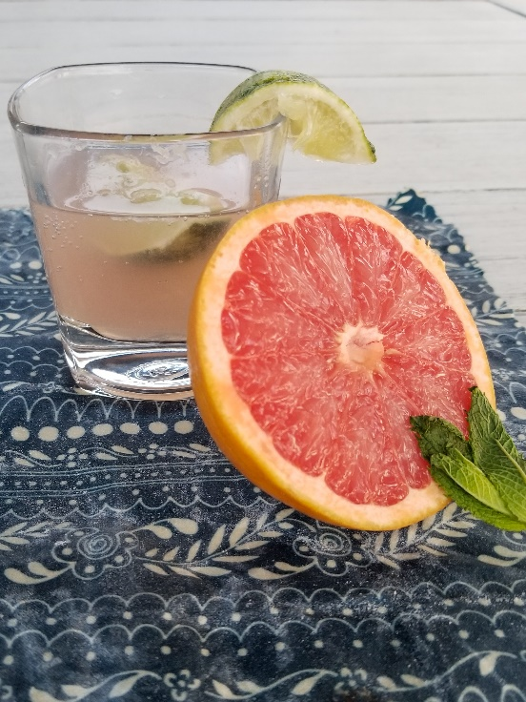
Servings 1 | Prep Time 5| Total Time 5
This mocktail offers classic refresh-mint! With no added sugar it’s a great alternative to soda.

Ingredients
1 Sprig (a few leaves) / Fresh Mint*
2 Slices / Lime*
2 Ounces / Pink Grapefruit Juice
4 Ounces / Soda Water
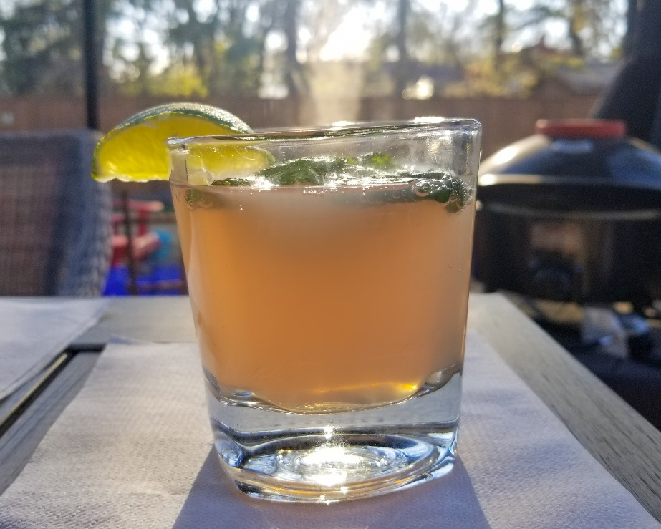
*more for optional garnish

Directions
Start by squeezing your limes into a glass. Then grab the mint leaves and rub them together before tossing them into the glass. I’ve read this will help to release those minty oils from the leaves, plus your hands will smell so fresh. It’s a win-win. Add some crushed ice to keep it cool. Add the Grapefruit juice and soda water. Finally give it a stir. Optional garnish with a lime wedge and a sprig of mint.
Now time to relax on the patio.

