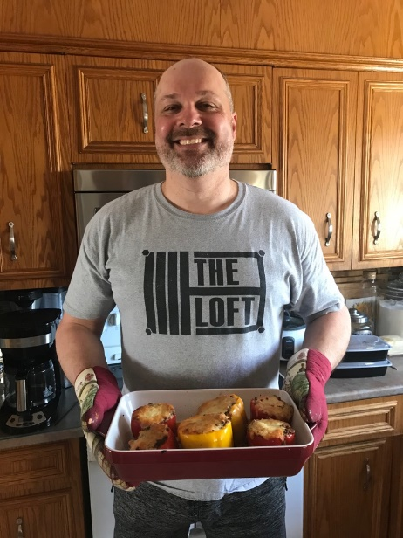
Rigs Stuffed Poppers by Rob Howarth
Ingredients
½ c uncooked rice
2 tbsp. extra-virgin olive oil plus more for drizzling
1 med onion chopped
1tbsp. tomato paste
3 cloves garlic, minced
1 lb. ground beef
1 (14.50z) can dice tomoatoes
1 tbsp. dried taco seasoning
Kosher Salt
Freshly ground black pepper
6 bell peppers, tops and cores removed
1 cup shredded Monterey Jack
Freshly chopped parsley, for garnish
Instructions
Preheat oven to 400 degrees. Place the rice and water in a saucepan, and bring to a boil. Reduce heat, cover, and cook 20 minutes. In a skillet over medium heat, cook the beef until evenly browned. Remove and discard the tops, seeds, and membranes of the bell peppers. Arrange peppers in a baking dish with the hollowed sides facing upward. (Slice the bottoms of the peppers if necessary so that they will stand upright. In a bowl, mix the ingredients and spoon an equal amount of the mixture into each hollowed pepper. Drizzle olive oil over peppers. Bake for 35 min covered with tinfoil, then remove foil and bake for another 10-15, until the peppers are tender.

