**Raspberry & Blueberry Scones by Lindsay Rowan**

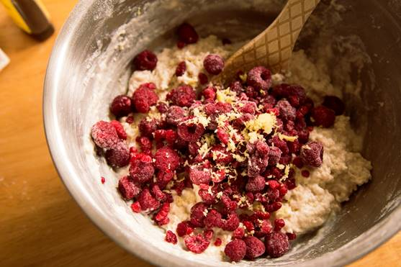**(Can be made Vegan!)**

* 3 cups of all-purpose flour
* 1/3 cup white granulated sugar
* 1 TBSP Baking powder
* 1 TSP salt
* ½ cup of butter or soy butter – melting
* ¾ cup to 1 cup of milk or almond milk
* 1 TSP of Vanilla
* 1 ½ cups of Raspberries or Blueberries
* 1 lemon to zest

Instructions

1. Preheat 375 F. Line large sheet pan with parchment paper
2. In large mixing bowl, whisk together the dry ingredients; flour, sugar, baking powder, salt.
3. Pour butter or soy butter into the bowl. Mix well together until it’s a shaggy sandy mixture
4. Drizzle the milk or almond milk, start with ¾ of the milk and Vanilla. Combined with a wood spoon or spatula. When the crumbs are mostly moistened, switch to using your hands. In separate bowl toss the berries of your choice in a little bit of flour than toss them into the bowl. Zest some of your lemon into bowl. Mix everything together! If it’s still to dry add the rest of the milk.
5. Scope with a hands or ice cream scope onto trays. Place in the oven between 20 to 30 mins

**Lemon Vanilla Icing**

1 cup of powdered sugar

1 TBSP Fresh lemon juice

½ tsp Vanilla Extract

**Lemon Icing**  – Small bowl stir together the powdered sugar, lemon juice and vanilla. Drizzle over the scones once they are out of the oven; use a fork!