PB Bananas Energy Balls by Evelyn Kampen
1/4 cup honey
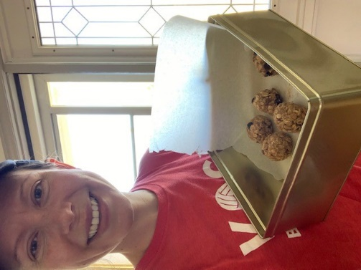
1/4 cup PB
1 banana
1 cup oats
+ as many choco chips as you want!
*Instructions: mash up your banana in a bowl, add honey + PB, then mix in oats and choco chips. Stir until well mixed. Refrigerate for 60-90 min and then roll into small balls.​ Once you are done - refrigerate again and enjoy as a snack anytime!

