Maple Mustard Salmon
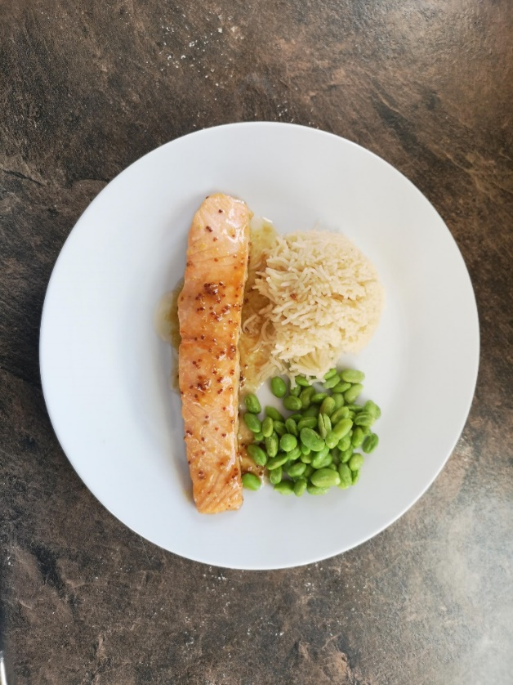
This is a quick and easy one from the Becel website.
- 1lb salmon fillet, bones removed and cut into 2 pieces
- ¼ cup margarine or butter
- ¼ cup pure maple syrup
- 4 tsp Dijon mustard or grainy Dijon mustard
- 1 tsp soy sauce

- Preheat oven to 425. Arrange salmon in an 8-inch baking dish
- Melt margarine/butter, combine with mustard, soy sauce and maple syrup
- Pour mixture over salmon. Bake 12-15 minutes or until salmon flakes with a fork. Serve hot with extra sauce over the top. Serve with rice.

