**Mango and Avocado Salad by Cristina Gomes**

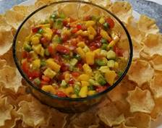**Ingredients**

1              avocado

1              ripe mango, peeled, pitted and diced

1              small red onion

¼ cup    chopped fresh cilantro (if you do not like cilantro you can use parsley)

2 TBSP  fresh lime juice

1TBSP    olive oil

½             red pepper (diced)

½             green pepper (diced)

In a bowl combine all ingredients together. Refrigerate and serve with tostitos

Enjoy ☺

This is a hit at potlucks and a favorite for summer BBQ’s