Chilli Paneer by Amrita Gill

Serves 2

Recipe Original from: Chef Kunal Kapur

https://www.youtube.com/watch?v=S9fskL5M9as&t=176s
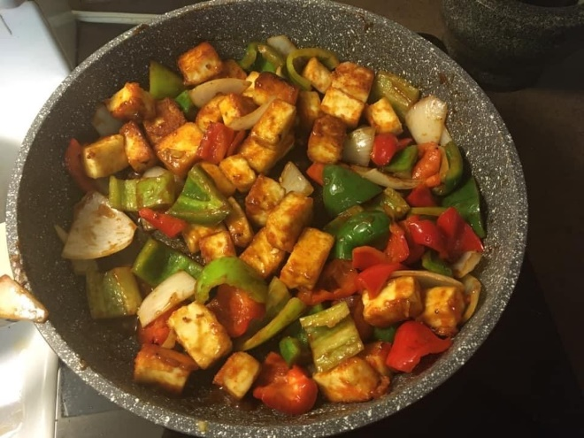
Ingredients
350 grams of paneer
1-2 tsp salt
1 tsp of chilli powder
2 tbsp corn flour (also known as corn starch)
2-3 tbsp oil
½ tbsp red chilli powder
½ tbsp of chopped garlic and ginger
½ cup of diced onions (large chunks – 1 cm)
¼ cup diced green peppers (large chunks – 1 cm)
¼ cup of diced red and yellow peppers (large chunks – 1 cm)
1 small chopped green chilli (optional)

Sauce
2 ¼ tbsp soya sauce (light)
2 tbsp ketchup
Pinch of sugar
½ tbsp white vinegar
1-2 tbsp of water

Steps
- Cut the paneer into 1 cm cubes
- Add the cubes to bowl, salt & add the chilli powder and corn flour. Mix gently with a spoon making sure that everything is combined and paneer cubes are evenly coated.
- Shallow fry the paneer in oil. Then set aside.
- In a small bowl combine red chilli powder with 1-2 tsp of water. Mix. Set aside.
- In the pan you used to fry the paneer, add some ginger and garlic and a bit of oil if needed. Stir approximately 30 seconds. Ensure it does not burn.
- Add the diced onion, green chilli, green, red, & yellow pepper and green chilli. Gently toss. 1-2 minutes.
- Add the red chili powder mixture. Toss. Then add the soya sauce, ketchup, pinch of sugar, & vinegar. Stir well. Add water if needed to increase quantity of sauce. 1-2 minutes.
- Add paneer to mix and toss everything together so sauce coats the vegetables and paneer.

