Chicken Tetrazzini by Alexis Reeves
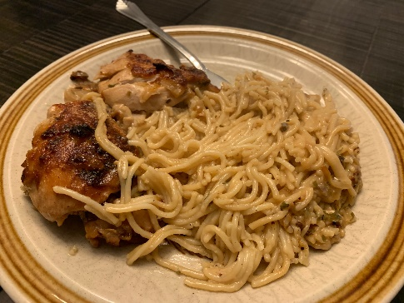
- ½ cup butter
- 2 large chopped onions
- 3 minced garlic cloves
- 8 skin-on chicken thighs
- 2 cans mushroom soup
- 1 cup water
- 1 tbsp. parsley
- 1 box spaghetti
- ¼ cup parmesan cheese

Fry onions and garlic in butter until browned. Add chicken and brown on both sides. Stir in soup, water and parsley. Simmer covered for 30 min.
Cook spaghetti minimum time. Drain and put in roaster. Arrange chicken on top of spaghetti, cover with sauce and sprinkle with parmesan.
Bake at 400 degrees for 30 min.

