Chicken Fingers by Megan Havens

Ingredients
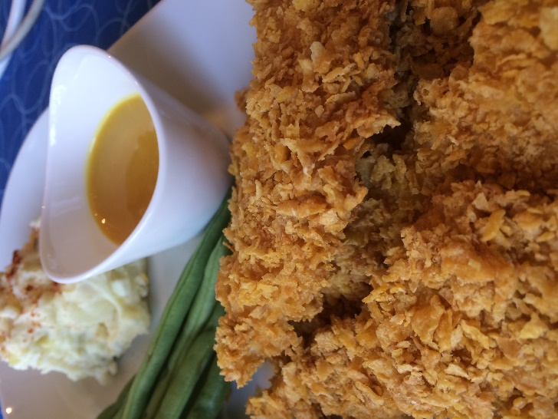
1 egg
½ c milk
1 tsp yellow mustard
½ c flour
2 c (plus) crushed corn flakes
1.5 lbs chicken breasts

Directions

- Cut chicken into strips
- Whisk together egg, milk, mustard and flour
- Dredge chicken in liquid then roll in crushed corn flakes
- Place on ungreased cooking sheet
- Bake at 350 degrees for 20 minutes or until internal temperature reaches 165 degrees
Honey mustard dipping sauce
¼ c honey
¼ c mustard
¼ c mayo
½ tsp Worcestershire

