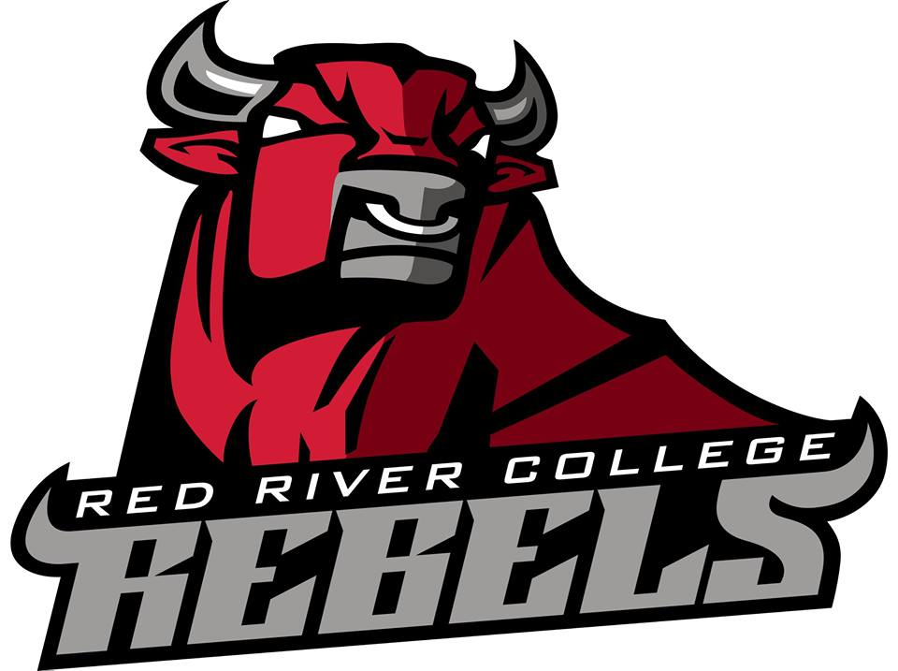
2018-19 Hockey Registration Form

Last name: | First name:
Cell #: | Daytime #
Email:

Emergency Contact Name: Emergency Contact #:
 | Please circle one: |  | Student | Staff |  | Associate |  |  | Alumni
Class |  | Day and Time |  |  | Dates |  | # of sessions | Location |  | Cost | Please Register me in
Fall Session |  | Tuesday 4:40-5:40pm |  |  | Oct 16,23,30  Nov 6,13,20,27  Dec 4,11,18 |  | 10 | Canlan Sports Centre |  | $110  XFITC
Winer Session |  | Tuesday 4:40-5:40pm |  |  | Jan 15,22,29  Feb 5,12,19,26  Mar 5,12,19 |  | 10 | Canlan Sports Centre |  | $110  XFITC
 |  | Total
GST
Please Circle form of payment: Cheque Cash Credit (Visa or MasterCard) Debit
 |  | Total Cost
Please complete this form and take it to Student Services Centre for payment. Prices DO NOT include GST. Student Services will keep this form and stamp with "Paid". Please keep your original receipt.

Rec Hockey Cancellation Policy
Full refund will be granted if you cancel on or before the first day of hockey. No refund will be granted if cancellation occurs after the start date with the exception due to medical reasons (requires a doctors note). Refunds will be prorated based on the number of sessions remaining in the schedule. Winter hockey maybe cancelled in the event of low registration. If this occurs a refund will be issued for the full amount. Note: All refund requests are being processed through a centralized system in financial services.
Equipment: No hockey equipment will be provided by Rec Services. Full equipment mandatory, and all facility rules specific to Canlan Sports must be adhered to. Each player must have one white and one dark jersey for each session. Cost is based on minimum numbers, may increase if not reached.

Informed Consent
I am requesting registration for the above Winter Hockey Sessions offered at Red River College by Recreation Services. I hereby affirm that I am in good physical condition and do not suffer from any disability which would prevent me or limit my participation in a session. In consideration of my participation in the session I release Red River College and Red River College employees from any claims, demands, and causes of action arising from my participation in Recreation Services hockey sessions. I fully understand that I may injure myself as a result of my participation, and I, hereby release Red River College from any liability now or in the future including, but not limited to heart attacks, muscle strain, pulls or tears, broken bones, shin splints, heat prostration, knee/lower back/foot injuries and any other illness, soreness or injury however caused, occurring during, or after my participation in the hockey sessions.
I hereby affirm that I have read and fully understand the above.

Date:

Print Name:
Signature:

