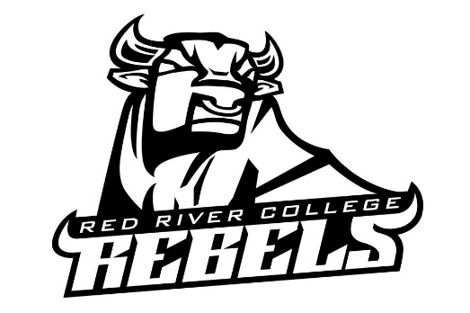
Intramural Supervisor Job Description
The Intramural Supervisor is to assist the Recreation Coordinator in running a safe, fun and successful Intramural program.

This position will allow the individual to gain experience for future jobs in recreation, community development and events/programming management.

They will gain communication skills: using appropriate language for communication, the message, and the audience. Gathering info from a variety of sources while using the most suitable tech to present info and ideas clearly. Improve Critical Thinking skills: Be able to apply independent analysis and logical deduction to make reasoned and ethical decisions. Gain Leadership experience: act responsibility, and communicate respectfully.

Primary functions;
- Attend all Intramural Events and sessions, acting as an on-site supervisor
- Ensure Facility is prepared before each game, including having all proper equipment ready for use.
- Adhere to the schedule set by Recreation Coordinator, ensuring games start and end on time.
- Checking to see that all players participating are eligible to play within the events/sports specific guidelines.
- Act has a referee/time keeper/scorekeeper when necessary.
- Report any incidents of poor sportsmanship, aggressive behavior or any altercations to the Recreation Supervisor or designate immediately after they occur.

Possible other functions include:
- Assist to develop and implement new ideas for marketing including but not limited to promotions, advertising and publicity
- Photograph events to update photo library and organize existing archives.
- Assist with the collection and organization of marketing research information
- Cultivate and organize student volunteers for Intramural Special Events.

Qualifications
- Able to balance school and work successfully
- General knowledge of sport and specific knowledge
- Excellent verbal and written communication skills
- Ability to work and meet deadlines independently
- Basic computer skills
- Willingness to be part of a team-oriented work group
- Positive attitude and excitement about the IM program
- Previous officiating experience and previous IM experience preferred

Required Availability:
- September to early April
- #3-4 hrs a week
- Intramural programs run weekday during the lunch hour.
- Intramural events run weekday nights and some weekends throughout the school year.
- Successful candidate would be expected to attend most events and program dates

To apply:
Submit a Rebels Athletics and Recreation Services Application Form, your cover letter and resume to Cole Skinner, Athletics and Recreation Coordinator via email at coskinner@rrc.ca.

