EASY TO FOLLOW PARKING GUIDE

Logging into Flexport
- Enter URL: https://rrcparking.t2hosted.ca
- From the Login page select Staff/Student Login if you are a current faculty/staff or a student.

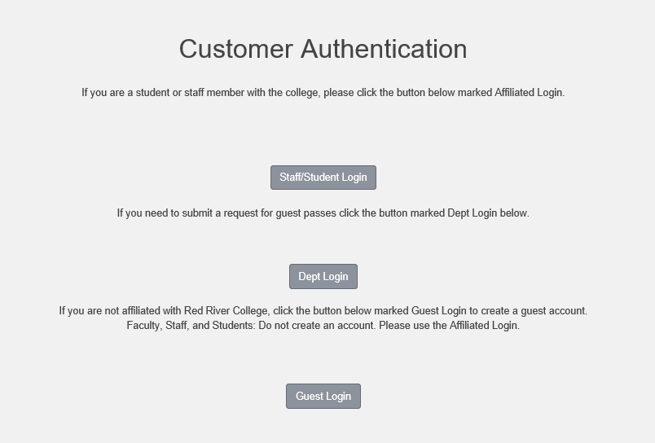

Parking Portal

- From the Parking Portal you will have the option to view permits, citations, and appeals

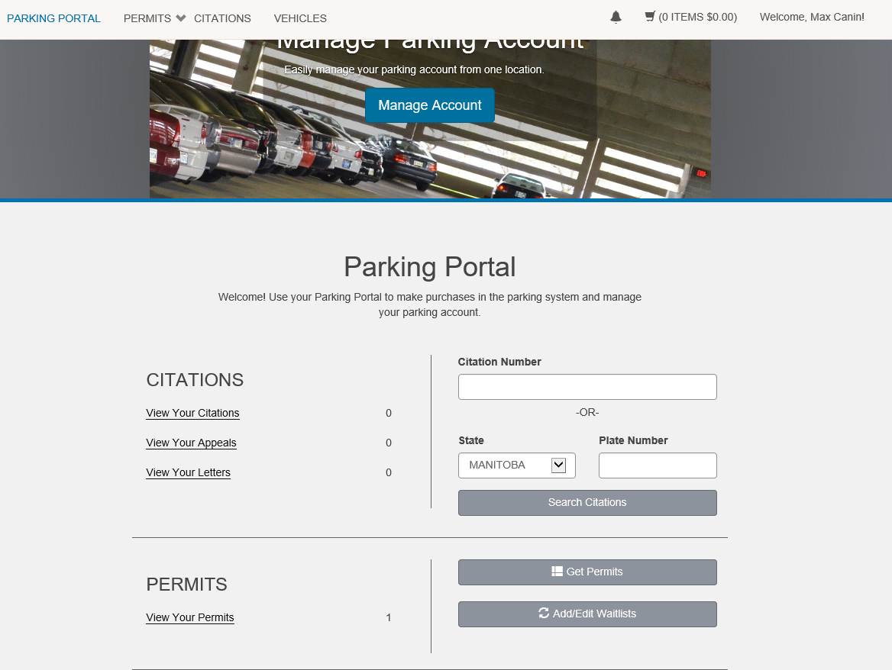

Purchasing a Permit
- Select Get Permits

- Read instructions carefully and proceed

- Select the permit you wish to purchase and agree to the terms (Please Note: Only permits you are eligible for will appear)

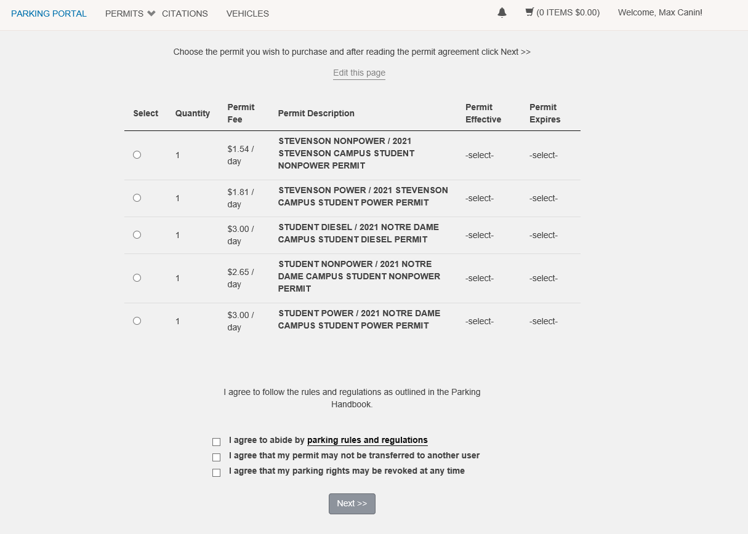

Select permit dates

- Select the effective start and end date for your selected permit

- You may select the start date of your permit up to 15 calendar days in advance.

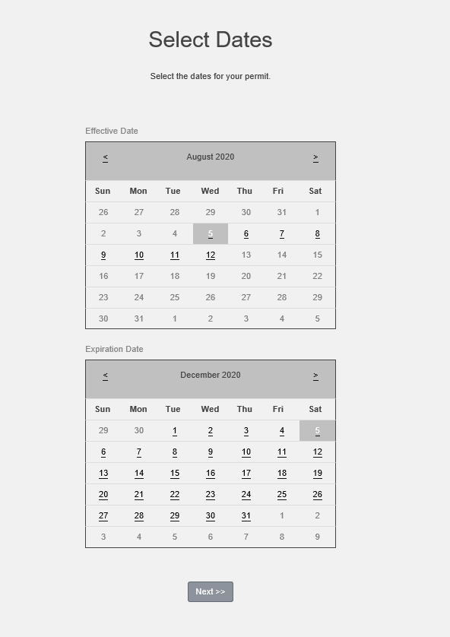

Confirm/register license plates

- Confirm which vehicle the permit is for (If vehicle is not listed select Add Vehicle and enter appropriate vehicle information). You may register up to four (4) license plates.

- It is the responsibility of the permit holder to ensure registered license plates are always current. Failure to register a license plate will result in citations issued.

- The permit holder is responsible for all citations issued on all registered license plates.

- If you have a license plate on your profile that you no longer use, you may disable it. The license plate will be inactive and will stay on your profile.

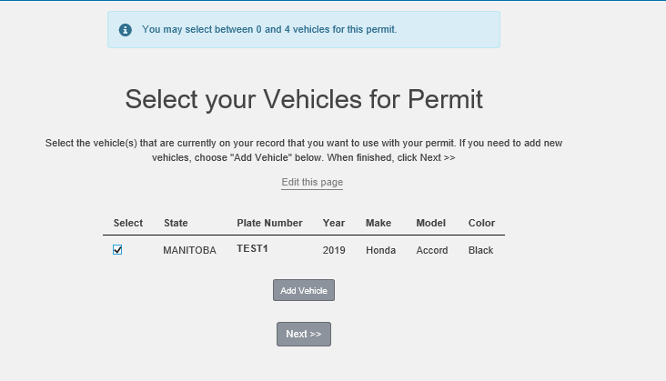

Your cart and payment

- Choose Payment Method and select Pay Now

- Please Note: -The permit you are purchasing is virtual. You will not receive a physical hangtag.
-If you require additional parking after his permit expires, it is your responsibility
to logon and purchase parking.

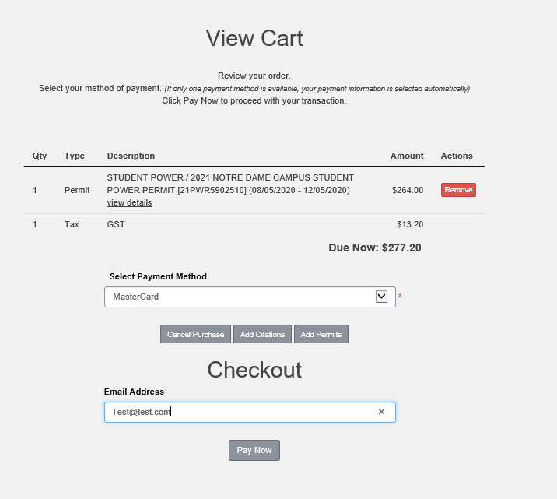

- Review Payment Confirmation

- Select Pay Now

- You will be rerouted to enter credit card information and returned to FlexPort for your receipt

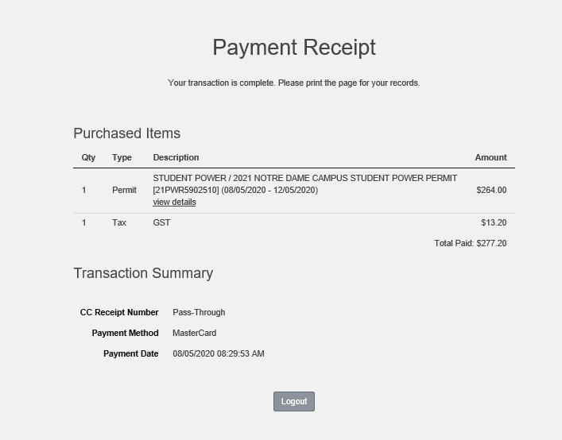

Citations
- From the Parking Portal select View Your Citations

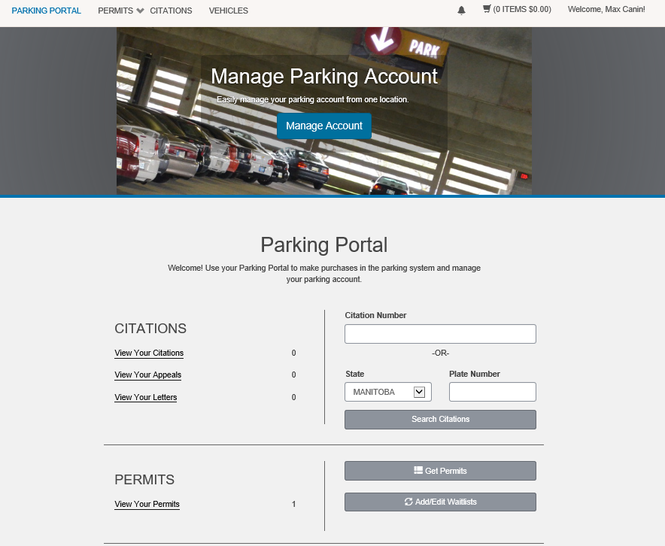

- This will show any past or present citations associated with your account and give you the option to pay or appeal your citation(s)

- Citations may only be appealed with-in fifteen (15) days from the date of issue.

- Citations issued for Parking in an accessible stall without authorization and Parking in a Fire Lane are not appealable.

- All citations will need to be Paid before they can be Appealed. We will cancel the citation if the appeal is successful and refund the citation fee.

View your Citations

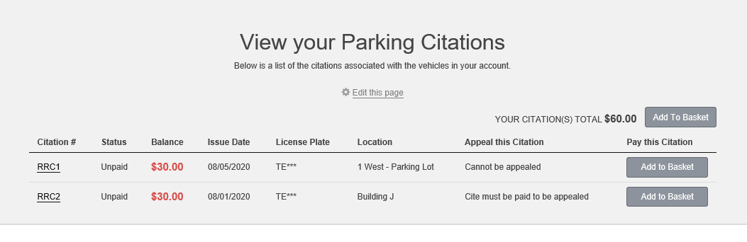

Paying a Citation
- To pay for a citation, select Add to Basket from the Citation Menu

- Once it has been added to basket select your Basket and click Pay Now

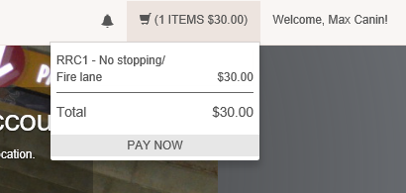

- You will be directed to your Cart

- Select Payment Method and click Pay Now

  - Review information in your cart (You will also have the option to Remove the citation from your cart).

  - You will be re-routed to enter credit card information and returned to FlexPort for your receipt.

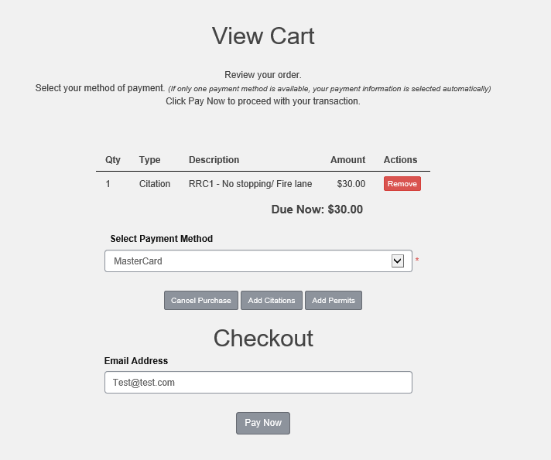

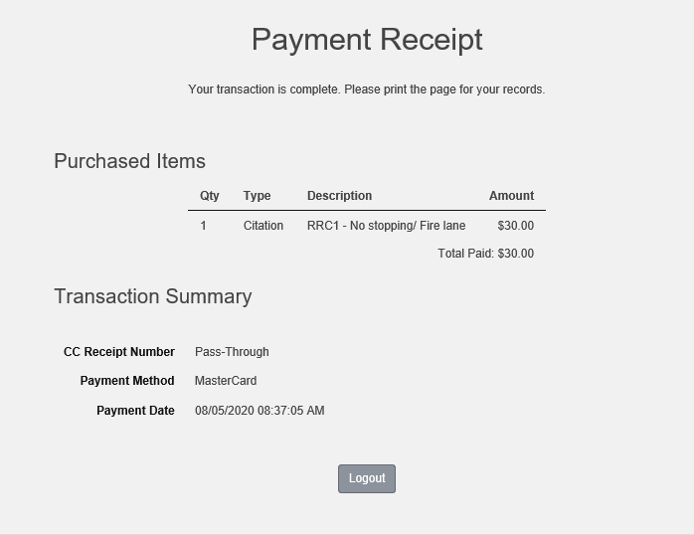

Appealing a Citation

Citations must be appealed with-in fifteen (15) days from the date of issue.
- Because all citations will need to be Paid before they can be Appealed, first pay off the citation you are looking to appeal.

- Once you have paid the citation, go back to the Citation Menu from the Parking Portal homepage.

- From the Citation Menu select Appeal on the citation

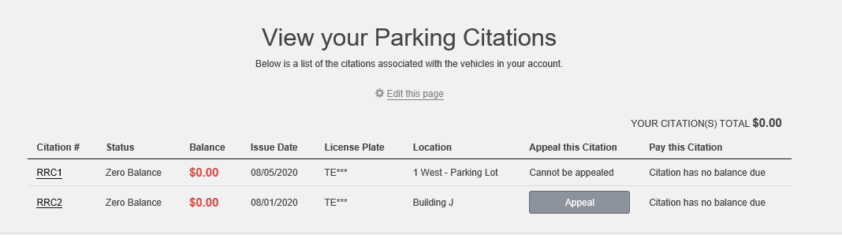

- Confirm the plate number of the vehicle associated with the citation

- Select Confirm

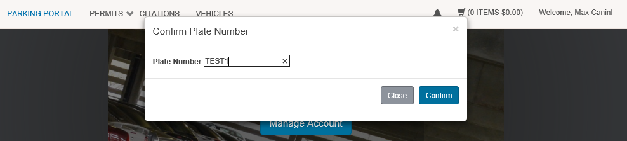

Review the citation details and select next once you have agreed with the information presented

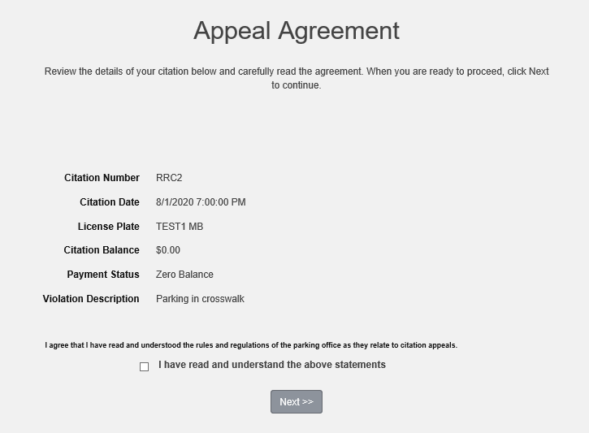

- Select email and address (You can add an email and address if one is not already in the system)

- Type the reason for the appeal

- You may add up to three attachments before submitting the appeal

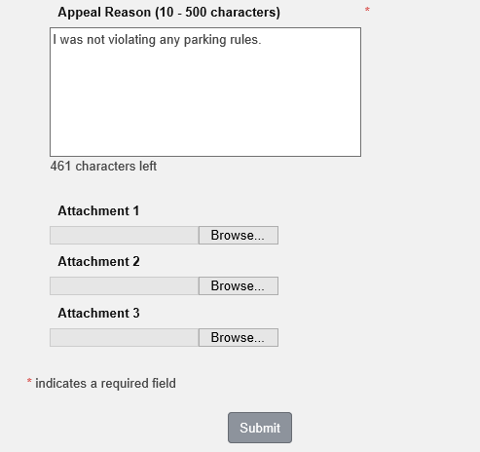

- You will be directed to the appeals receipt

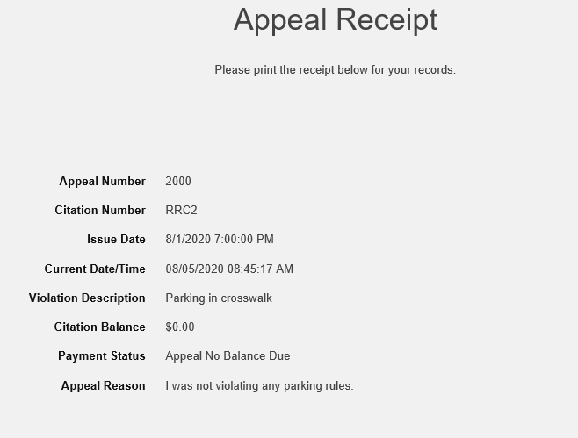
- We will review your appeal and email you a decision to the email you provided on the appeal form.

Questions?
Contact us at parking@rrc.ca

