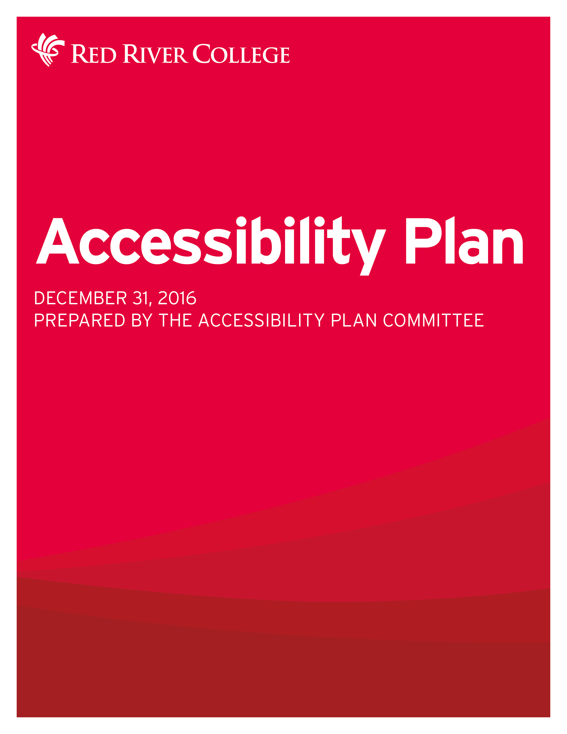

MESSAGE FROM PAUL VOGT, PRESIDENT AND CEO
At Red River College, we have a very successful practice of creating an environment that supports the needs of our students, employees and the broader community, in our pursuit to create a welcoming, open and accessible College.
It’s important that this practice extend across all of our campuses, and that we have the right plan, and the right resources in place to ensure that we can continue this practice of being a supportive and inclusive community.
As one of the largest post-secondary institutions in Manitoba and a leading employer, we’re proud that we have cultivated a community that embraces accessibility, diversity and inclusion, and one that also provides equality of opportunity, and recognizes the dignity of all people.
Our new Accessibility Plan, which has been guided by a College-wide team, allowed us to explore our current practices and to engage with a very diverse cross-section of our College community to identify new opportunities to increase accessibility at Red River College.
I want to commend the work of our Accessibility Steering committee. Their dedication to this process has allowed for the creation of this comprehensive plan that will ensure our College meets the requirements of the Accessibility for Manitobans Act, in addition to providing a roadmap to help us continue to enhance the supports and services we offer at all of our campuses.
As a College we value learning, respect, inclusiveness, integrity, sustainability and service to community, and I believe this plan embodies our College’s core values, while also charting a course to ensure that Red River College will continue to be an inclusive campus for all.
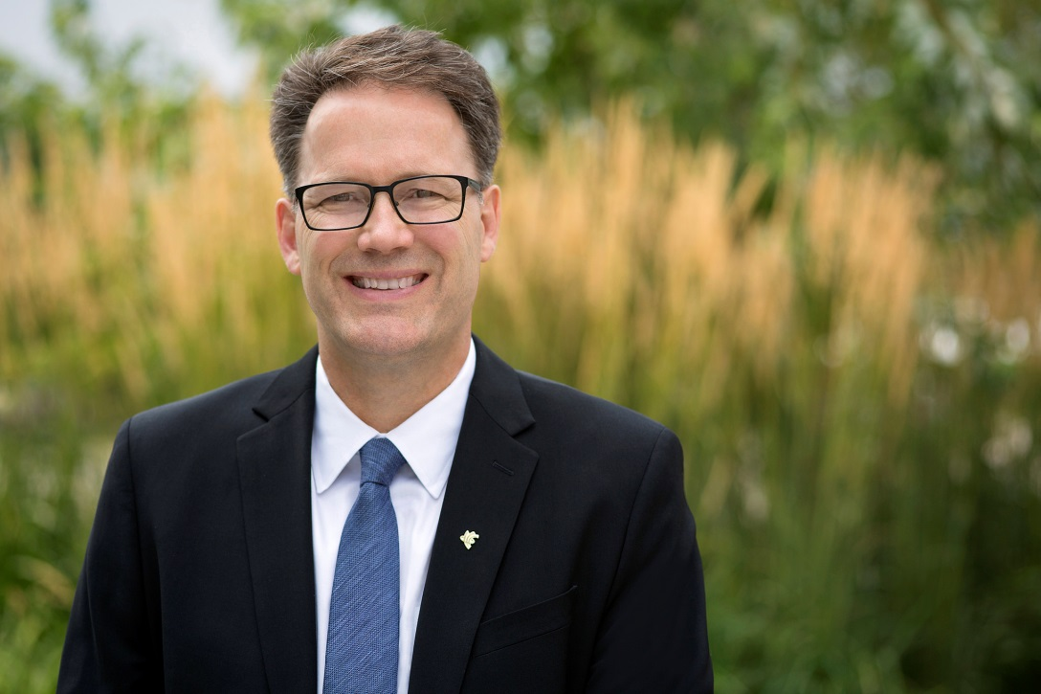

Introduction
In 2013, the Province of Manitoba announced the Accessibilities for Manitobans Act, which requires organizations to develop and implement plans to enhance accessibility in five areas: Customer Service, Employment, Information and Communications, Built Environment and Transportation.
The Act focuses first on government and publicly funded organizations, including post-secondary institutions to meet the standards as they are released over several years.
The first standards for Customer Service came into effect November 1, 2015, with compliance required by November 1, 2017. This plan addresses meeting and exceeding those standards while laying the groundwork for future standards as they are rolled out. Each year the plan will be reviewed and updated, ensuring Red River College is prioritizing the removal of barriers to accessibility.

Accessibility Plan Committee
The plan was developed by the Accessibility Plan Committee under the direction of the Chief Human Resource Officer, Lori Grandmont and Vice President, Finance and Administration, Debbie Frankel. The role of this committee is to facilitate the extensive research and consultations required, develop and maintain the rolling plan, and monitor the subsequent implementation of identified actions. The committee can be reached at accessibilityplan@rrc.ca

Committee members:

- Neil Cooke, Education, Curriculum and Learn
- Nancy Cumbers, Human Resources (Chair)
- Lori Grenkow, Regional Campuses
- Megan Havens, Public Relations and Communication
- Jason Ilagan, Building Systems and Maintenance
- Lynda Joyal, Finance and Campus Services
- Michael Krywy, Research and Planning
- Sherrie Novak, Staff Learning and Development
- Albert Podzorski, Building Systems and Maintenance
- Dave Rogalsky, Student Support Services
- Tom Skraba, Building Systems and Maintenance

Research Methodology
- Creation of an advisory group
- Key informant interviews with internal stakeholders
- Focus groups with internal stakeholders
- External stakeholder interviews
- Surveys with employees (with and without disabilities), students (with and without disabilities)
- Review of plan by senior management
- Sharing draft of plan internally for comment
- Sign-off of plan by key stakeholders tasked with implementation
- Creation of a governance group to track progress of the plan

Baseline Report

Overview / Background
Red River College has a longstanding and very successful practice of identifying barriers to accessibility and implementing practical changes to meet the needs of our students, employees and the broader community. As a community, RRC employees take pride in this work because everyone plays an important role in making the College an open and accessible community that helps to foster success for all.
Every year, the College provides services to a large number of students with a broad spectrum of disabilities. Last year, RRC had 1,126 students self-identify with the Accessibility Services department as having a disability or disabilities. Among these students:
- 422 had a mental health disability
- 318 had a learning disability
- 169 had a physical disability
- 43 had Autism Spectrum Disorder (ASD)
- 40 were hard of hearing and 38 were Deaf
- 14 were blind or partially sighted

The College’s Academic Accommodations Policy (Policy A28) provides clear guidelines regarding the processes for providing appropriate accommodation to students with disabilities. Last year the following services were provided to students with disabilities:
- 239 received professional tutoring
- 377 registered for exam accommodations
- 30 received assistive technology
- 59 received alternate format print
- 18 had psycho-educational assessments to confirm a disability
- Computerized note-taking
- American Sign Language interpreters
- Classroom accommodations such as audio-recording of lectures, copies of instructor resources, preferential seating, flexibility around attendance and assignment deadlines, reduced course loads, ergonomic chairs, height adjustable desks

Overall, the College has significant in-house expertise in working with students with disabilities, as well as strong relationships with external disability stakeholders who are frequently consulted with and relied on for their expertise.

However, the strategies for ensuring accessibility go beyond the direct academic supports provided to students. The College has also begun implementing the new Customer Service Standard for persons with disabilities, which builds upon current best practices. Similarly the College’s website is in the process of being upgraded to meet current accessibility standards, as are many of the College’s other communications tools. In the built environment, the College’s two most recent building projects – the Paterson GlobalFoods Institute and the Skilled Trades and Technology Centre – have been designed to meet or exceed current accessibility standards.
The College also prides itself on being a Top Employer, which includes taking steps to ensure it follows the principle of inclusiveness in all its practices. Red River College currently employs an estimated 50 self-identified persons with disabilities, although it is currently in the process of completing a workforce audit. It also has a range of accommodations it can provide, including ergonomic work station modifications, a cost-shared health benefit plan, and human resource strategies to work with employees to remove barriers within the work environment.
Despite these accomplishments, there are always opportunities to improve accessibility. The process that led to the development of this Accessibility Plan revealed many achievements, but also some barriers that need to be addressed. While all of the College’s main information and communications systems are accessibility compliant, some systems are not. Best practices for creating accessible user-generated content – such as course notes, videos and blog posts to name a few examples – have not been clearly defined. When it comes to creating academic content, the College is in the early stages of implementing Universal Design for Learning principles (), which will in turn benefit all students.
While newly built environments are accessibility compliant, older buildings (some of which are leased by the College) have features that are not compliant. The process for identifying, prioritizing and resourcing potential changes also needs to be improved.
Improving accessibility on the academic side is equally challenging, but also promising in that it will lead to an overall improvement in the quality of education. The College needs to continue to examine and define “Bona Fide Academic Requirements” also known as “Essential Learning Outcomes ()” so that it can appropriately guide admissions, instructional practices, and the application of the Academic Accommodations policy. Given the uniqueness and complexity of College programs, significant consultation and examination of the College’s academic programming lies ahead. The College must also look for ways to enable students to self-identify as early as possible pre-entry, so the appropriate assessments, conversations and strategies can be put in place to mitigate barriers and effectively accommodate and support students.
This two-year rolling plan will provide the foundation and direction for beginning to address these and other issues. Fortunately, there are many current practices in place, as well as expertise throughout the organization to reach these goals. Some of these goals are cultural and attitudinal; others require changing practices and adding resources. The end result will benefit all employees and students, and continue to foster traditions of excellence at the College.

Information and Communication
Red River College shares information and communication with many audiences – employees, students and the public – through a variety of channels. These include:
- The RRC website (rrc.ca) combines centrally managed pages as well as content developed by work areas (typically on “microsites”).
- The RRC intranet and other systems are available to employees and students via authenticated login. The intranet contains approximately 200 different tools/systems created by a variety of internal and external developers. Some of the main systems are WebAdvisor, SharePoint, Colleague and LEARN (Brightspace). These systems are used to facilitate learning, manage enrolments, monitor student achievement and collect employees information (e.g., T4 slips).
- Marketing communications that may include print, video and other media. These communications are typically centrally managed.
- User-generated content is content that is created by employees, departments, committees, etc., and is typically not centrally managed. Some of this content is delivered through the College’s Learning Management System (D2L Brightspace branded as LEARN), microsites, and other media.
- Signage is a final major component, as it helps to support wayfinding throughout College buildings.
Area | Barriers | Achievement
RRC website | The current website is not governed by a single accessibility standard. As a result, some features/pages may not be accessibility compliant. | . Until the new site can be launched with Web Content Accessibility Guidelines (WCAG) 2.0 at Level A the current site has been updated to meet this accessibility standard to the extent possible.
RRC intranet and other systems | Some content uploaded to our major systems is not designed to meet accessibility standards. | Major systems, such as Colleague, WebAdvisor and Self-Serve conform to the US accessibility standard 508.
 | The majority of the intranet tools have not been consciously built/implemented with accessibility in mind. | A major component of the intranet, “SHARE” is a SharePoint site and currently has some accessibility features with more being added.  The College’s Learning Management System (Brightspace) is also 508 compliant and enables students to access content in multiple formats.
 | All employees are using Microsoft Office 2010 or higher on their desktops, but some may not be aware of the Accessibility review functionality built into the product. | Some employees are aware of and use these functions.
 | The process for purchasing/designing intranet systems has not historically had accessibility criteria as part of the procurement process. | Accessibility criteria have recently been added to the procurement process.
Marketing | Viewbook and other program/course marketing materials are available in print and PDF versions, and may not be accessible for screen-readers. | All branded projects through the Marketing department follow best practices on contrast, font size, etc.
User-generated content | There are no College-wide standards/practices governing the design of academic content for the purpose of accessibility. | The College is currently developing best practices for the development of course content following Universal Design for Learning principles.
 | There are no College-wide standards/practices governing the design of other user-generated content for the purpose of accessibility (i.e., blog posts, meeting documents, news releases etc.). | The College is currently developing best practices for the development of user-generated content.
Signage | Some older signage is not compliant. | Newer signage has been designed to be compliant.
 | Many employees and students have cited the lack of effective signage for identifying how to access elevators at the Notre Dame Campus. | The College has recently updated wayfinding signage at the Notre Dame Campus that has larger text and pictographic descriptions.

Direct Support
Given the multi-faceted nature of a post-secondary institution like Red River College, there are many ways in which employees, students and the public personally engage and interact with each other. These interactions have been grouped together under the category of “direct support” which generically refers to customer services, academic and employment practices, and employees and student services.
To summarize, the four main areas of direct support have been grouped as follows:
- Design and delivery of academic programming. These two aspects of the learning environment – academic design and its delivery – are intricately linked. Academic design is critically important, as it includes the learning outcomes for a program, the applied and theoretical skills that a student must master, and the learning environments that students encounters. Academic delivery focuses on the interaction between instructors and students, and focuses more on the presentation of materials, assessment practices and instructional methods. Given the range of diverse programming, the breadth of faculty involved, and the range of barriers and academic accommodations that are potentially required, a complex array of issues emerge in this area.
- Student and enrolment services refer to all the activities, policies and processes that are used to support current and prospective students. For several decades, the College has provided accommodations for students with disabilities, such as Deaf and hard of hearing services, counselling and accessibility services, and exam accommodations. It also has specialists within other areas, such as the Academic Success Centre, that provide tutoring and other academic supports. Student services are typically provided as an integrated support to those provided by instructors.
- Human resources and employee development services include the policies, practices, services and supports that are related to employees, as opposed to students. This includes hiring practices (including employment equity), policies (e.g., the Discrimination and Harassment policy), and the ongoing engagement with employees through employee development. It also covers employee supports (such as employee health benefits), and management practices. While some accessibility strategies are College-wide, others are targeted to individuals or work units.
- Campus and ancillary services include a wide range of processes and services that engage employees, students and the public as “customers.” Examples of these types of services include parking services, food services and any other processes that connect employees with the general public, industry and the community.

Area | Barriers | Achievement
Design and delivery of academic programming | There is no formal training related to the College’s Academic Accommodations policy (A28), however general knowledge is evident. | The College has an Academic Accommodations Policy (A28) that includes definitions, principles, processes, confidentiality and responsibilities of all RRC employees.  Training is delivered via presentations to faculty on request, Faculty Reference Guide for Assisting Students with Disabilities and other resources, and through stewarding the accommodations plan. Workshops/presentations are provided in the CAE course “Diversity and Inclusiveness” as well as when opportunities allow for faculty development.
 | While all programs have learning outcomes, many have not defined the “essential learning outcomes” which are the requirements that all students must meet in a program. These are also known as Bona Fide Academic Requirements. | In the process of developing Academic Accommodation plans, essential learning outcomes have been identified for specific programs.
 | Some course outlines do not have the Accessibility Statement in them. | An Accessibility Statement is included in all new course outlines, as well as all course outlines that are reviewed. Previously, inclusion of this statement was optional.
 | There are limited pathways for students with disabilities who would not meet admission requirements for most programs due to significant related barriers. | The Transforming Futures pilot project was created to explore opportunities in this area. The program was subsidized with external funding and is currently being evaluated.
Student and Enrolment Services | Self-identification processes can result in some students with disabilities either not being identified pre-entry or identifying while already in the program. Late identification often precludes timely accommodation planning. | The enrolment form enables students to self-identify. There is also an opportunity for students to self-identify and directly connect with the program and/or accessibility services pre-entry or during the program.  Faculty and other academic staff may also refer students, as do some high school counsellors.  If an applicant self-identifies, they are provided with information regarding Accessibility Services, including how to connect and what they need to do to initiate the accommodation planning process.
Student and Enrolment Services | Significant time and resources are often required to create an Academic Accommodations plan and implement it in a timely manner.  Given the complexity and uniqueness of programs and the variety of student needs, the processes are often reactive and time intensive, and draw upon already scarce resources. | Every student is unique in their needs, and approaches/solutions are unique to support these needs. There are numerous cases where complex Academic Accommodation plans have been developed and implemented, and have led to student success.
 | Historically, there were situations when students self-identified as having a disability and faculty were unaware that accommodation may be required. | A new communication process has been implemented in the last 18 months to improve the sharing of information between Student Services and academic programs. However, students need to provide consent for this information to be shared.
 | Students who have a disability but lack a clinical assessment may struggle to have an assessment completed while in program due to the time required, the cost, and lack of awareness of the process. | RRC offers a very limited number of psycho-educational assessments, depending on the nature of the disability.  Accessibility Services also provides standard accommodations in the interim to allow for an assessment to take place and until additional information can be provided to develop a more comprehensive accommodation plan.
 | There are differences in the processes for assessing and supporting students with disabilities in the K-12 system compared to College. This can create unrealistic expectations for some students, given the different processes and levels of service. | The College has worked with high school counsellors to advise them of the differences between the systems, so they can then properly advise students who are considering going to college.
 | The demand for services is greater than the resources available, which can lead to a delay in the development and implementation of an accommodation plan. | Last year the College provided supports to 1,126 students with disabilities, including: counselling, tutoring, exam accommodations, assistive technology, alternate format, computerized note-taking, ASL interpreting and various classroom accommodations.
 | The majority of in-person services are available at the Notre Dame Campus, and secondarily at the Exchange District Campus. This creates challenges in understanding and assessing a student’s need for accommodation, particularly when they are at a regional campus or taking courses through distance education/online. The development and implementation of an accommodation plan is very difficult from a distance. | There has been an increase in electronic services (e.g. tutoring via Skype, phone and email) to reduce in-person meetings.  There are also scheduled visitations to regional campuses.
 | Mental health-related issues are on the rise, and many employees may be unaware of how to appropriately support those with these types of issues. | The College ran a mental health pilot initiative in 2014/15, called Healthy Minds/Healthy College, focusing on employee and student mental health, which included the creation of the Mind It website as well as the recent hiring of a Mental Health Coordinator.
 | There are limited financial supports available to students with disabilities. | The College offers awards and bursaries for students with disabilities. Four Student with Disability awards of $500 each were distributed, as well as five Crisis Bursaries to students with disabilities at $500 each, for a total of $4,500
 | Some employees are unclear of the legal processes (e.g., FIPPA, PHIA) that govern the sharing of information. | The College has begun providing College-wide FIPPA and PHIA training.  Confidentiality is also covered under the Academic Accommodations Policy.
Human Resources and Staff Development | Many employees have never received training related to accessibility (physical and/or attitudinal) as there is no College-wide process or materials in place. | The College provides opportunities to access training, participate in events, and engage directly with internal and external disability experts.  For example: Mental Health First Aid Workshops were introduced in 2014 and are now offered continuously, and the College promotes and participates in events such as Mental Health Week and the Wellness Expo.  College-wide training is currently being developed through a consortium of Manitoba post-secondary institutions. Training videos will be available in November 2016.
 | Most staff development workshops/training have a single delivery method, which may create accessibility barriers for some employees. | The College is currently exploring multiple format delivery.
 | Events that are not coordinated by the Events Manager do not always consider accessibility issues when planning the event. | Events coordinated by the Events Manager are planned with accessibility in mind. For example, American Sign Language Interpreters are used during College-wide presidential speeches. Similarly, event locations are typically chosen to ensure physical accessibility.
 | Some employees say there remains a stigma attached to disclosing a disability, particularly when accommodations are required. | Many employees have successfully had an accommodations plan implemented and fully supported by management.
Campus and ancillary services | There has not been any College-wide customer service training for staff in providing campus and ancillary services. | Some areas have addressed this as part of general customer service training, as was the case with the College Book Store. (Campus Store)
 | Many customer service staff are unaware of how to access advice/information when they have questions related to accessibility. | Through experience, some areas have developed internal expertise and/or connected with experts within the College to effectively mitigate barriers.

Building Services and Transportation
Red River College delivers programming across nine campuses in Winnipeg and southern Manitoba, in addition to other locations where it delivers training on-site.
The largest is the Notre Dame Campus (NDC) located on Notre Dame Avenue in Winnipeg, which was built in 1963 and until recently was owned and operated by the provincial government. In the last decade, the campus has seen several new buildings constructed on-site, including the Heavy Equipment Transportation Centre (HETC) and the Skilled Trades and Technology Centre (STTC), which is currently under construction.
In 2002, the College significantly expanded operations by moving into the Exchange District Campus (EDC), where it now operates in three buildings: the Roblin Centre (opened in 2003), the Paterson GlobalFoods Institute and student residence (PGI, opened in 2013) and the Massey Building, where the College leases space.
RRC also runs Winnipeg-based programming at its Language Training Centre (LTC, located in the VIA train station at Main and Broadway), its Stevenson Campus (Aviation and Aerospace), and several other specialized training centres (such as its Railway Conductor field training site).
Outside of Winnipeg, Red River College has campuses in Steinbach, Portage La Prairie (a main campus and a second Stevenson Campus), Winkler, and the Interlake (Selkirk and Peguis – Fisher River).
With such a large array of buildings and locations, there are several characteristics that are worth focusing on when considering accessibility issues:
- Characteristics of the building – this includes ownership or tenancy, when the building was constructed, and the building’s renovation history.
- Processes – this includes how the College plans and prioritizes work, and the relationship it has with landlords who own the buildings we lease or operate within.
- Transportation – this includes ownership and designation of accessible parking spaces, access to campuses with respect to public transportation, and other strategies to mitigate transportation barriers.
Area | Barriers | Achievement
Characteristics of the building | The College has limited influence over leased buildings. | There have been times when improvements have been made by the landlords to increase accessibility. For example, the department of Manitoba Infrastructure and Transportation recently made several changes to improve accessibility at NDC, such as renovating the entrance to Building D to include a ramp.
 | Buildings that are built to previous accessibility standards can be challenging to upgrade to modern standards. Retrofitting to meet newer standards is typically more expensive than newly built construction. Retrofitting can also be challenging due to space requirements, design and engineering. | There have been many building upgrades to mitigate accessibility barriers. For example, at NDC there are automated door openers, braille and voice in elevators, and all washrooms are now barrier-free to recent standards.
 | Current spaces used for trades and technology programming have some accessibility barriers. For example, Building B has no accessible ramps. | New buildings are designed to meet or exceed accessibility standards. For example the Skilled Trades and Technology Centre is being built to exceed current accessibility standards.
Processes | Only the NDC campus has undergone an audit for accessibility, the last occurring in 2006 (NDC Accessibility & Universal Design Site Assessment). The methodology was not outlined in the report and only select areas were audited as samples. | The NDC audit, although slightly dated, provides a baseline report for documenting the accessibility status of this campus. The College also has an inventory of equipment and facilities to help with planning for future renovations and upgrades.
 | Some individuals are unaware of the process for submitting requests to change/improve accessibility in the built environment. | The work order process is used to manage accessibility improvements to the built environment.  Once a work order is submitted, projects are tracked and prioritized, and can result in improvements that mitigate accessibility barriers.  Students can also provide feedback about accessibility and the physical environment by submitting their concerns in writing to Accessibility Services, who in turn provides the information to Facilities for a response.
 | Some employees are unaware of the process for requesting workplace accommodations, while others have been frustrated when requests have been rejected. | Accommodations have been made to both educational and employee workspaces to facilitate ergonomic needs. For example, stand-up desks, wheelchair-accessible workstations, and modification of workspaces.
Transportation | Several campuses are not accessible to public transportation, including Stevenson Aviation in Winnipeg and Southport. | The majority of campuses are serviced by public transportation, including NDC, the EDC, and the LTC.  EcoPasses are available to all employees and have been integrated with Handi-Transit to provide an employer-subsidized accessible transportation solution.
 | Some RRC campuses have limited parking spaces owned by the College. For example, most of the spaces around EDC are privately owned or owned by the City of Winnipeg (i.e., street parking). | Both NDC and EDC have designated accessible parking spaces.

Action Plan

Statement of Commitment
Red River College is committed to developing a culture of diversity and inclusivity for the communities we serve. We believe in equal access to education, and as one of the province’s leading post-secondary institutions, we are committed to fostering an environment that is welcoming, supportive and respectful of the dignity and independence of people with disabilities.
Red River College is committed to continuing its work to remove barriers to post-secondary education, and to promote access and participation in all aspects and activities of the College. Building on decades of inclusion and the establishment of best practices, it is the responsibility of each member of the College community — including employees, students, alumni, volunteers and their representative organizations — to play a part in creating an equitable and inclusive environment. While individuals must satisfy the requirement of their course of study or employment, we commit to making reasonable accommodations that may be required to allow persons with disabilities to be successful.
We believe in inclusion and we will continue our work to meet, and exceed where possible, the mandate of The Accessibility for Manitobans Act (AMA).

General
Area | Strategy | Expected Outcomes
 | Define ownership/governance of the plan. | Responsibilities will be clearly defined and managed during this two year phase.
 | Provide mandatory training to improve overall understanding of accessibility for persons with disabilities. | Increase knowledge and awareness, and reduce stigma.
 | Develop a strategy for sharing resources and communicating with employees, students and stakeholders. | Increased knowledge and easier access to resources and information.
 | Make it clear that alternate formats for all communication materials are available upon request. | Include alternate format statement on all communications.

Information and Communications
Area | Initiatives/Actions | Expected Outcomes
RRC website | Implement or upgrade Content Management System (CMS) to power websites to the proposed accessibility standard. | Accessibility-compliant website.
RRC intranet and other information systems | Review intranet and other systems to identify accessibility compliance and gaps, leveraging the current review process. | New accessibility-compliant systems will be implemented upon approval.
 | Continue to migrate course content onto LEARN, to take advantage of accessibility features. | Increase the percentage of course content available on LEARN.
 | When purchasing or developing new systems, include accessibility standards as part of the overall criteria. | New accessibility-compliant systems will be implemented upon approval.
Marketing | Create process for providing closed captioning to new video materials and previously developed priority materials. | Increase in the number of videos available with closed captioning.
User-generated content | Develop accessibility guidelines/standards for academic content. | Guidelines created and distributed.
 | Develop accessibility guidelines/standards for other user generated content. | Guidelines created and distributed.
 | Provide training/resources related to that standard for all user-generated content, and ensure that all new content meets the new guidelines/standards. | Have training available to employees.
Signage | Develop a strategy for upgrading signage. | Strategy established, with some increase in new signage that is accessibility-compliant.
 | Improve wayfinding signage to help people locate elevators at the Notre Dame Campus. | Signage implemented.

Direct Support
Area | Initiatives/Actions | Expected Outcomes
Design and delivery of academic programming | Promote accessibility information and tools for faculty. | More faculty are aware of and using resources.
 | Develop and deliver an online module related to the Academic Accommodation Policy (A28) | Increased awareness of the Academic Accommodations Policy (A28)
 | Provide training to new instructors as part of the Teaching Essential Program (TEP). | Information on Academic Accommodations policy and processes included in the TEP.
 | Begin the process of defining essential learning outcomes, drawing on the expertise of Program and Curriculum Development, Academics, and Student Services. | Process defined.
 | Ensure that all course outlines include the Accessibility Statement. | All course outlines will include the Accessibility Statement.
 | Review the evaluation of the Transforming Futures pilot project and develop a strategy based on the recommendations. | Review completed.
Student and enrolment services | Form task group to improve self-declaration process. | Improved processes for student self-identification.
 | Develop additional readiness strategies specific to students with disabilities to ensure that students are appropriately prepared for the start of classes. Also ensure that admission requirements are clearly stated. | Improvement in student readiness.
 | Review process for developing student Academic Accommodation Plans. | Process for Academic Accommodation Planning is defined and communicated to employees.
 | Review barriers to enhancing student services beyond the Notre Dame and Exchange District campuses. This would include assessing technology, internet connectivity, space and resources. | Develop strategy to enhance student services.
 | Develop a Mental Health Strategy for all employee and students. | Mental Health Strategy.
 | Explore options to reduce financial barriers to students with disabilities, such as site licenses for assistive technology. | Report outlining strategies to reduce financial barriers.
Human resources and staff development | Review policies on recruitment, staffing, selection procedures and accommodation for employees. | Updated policies, as per recommendations of review.
 | Deliver the required Accessibility for Manitobans online training modules to all RRC employees. | All employees will receive training by November 2017.
 | Increase College-wide employee training on core accessibility topics (e.g., duty to accommodate, mental health, customer service, etc.). | Majority of employees have received training.
 | Begin delivery of staff development workshops using multiple format delivery. | Targeted Staff development workshops are delivered using multiple format delivery.
 | Provide training for all managers in regards to staff accommodations, and how to ensure employees who have been away are able/ready to return to work and appropriately accommodated when they return. | Training provided to all managers.
 | Provide information/training on how to plan an accessible event. | Accessibility check list developed.
Campus and ancillary services | Deliver College-wide customer service training on the Accessibility for Manitobans Act. | All employees who provide customer service will receive training by November 2017.
 | Ensure that employees know who to contact and where to get information related to customer service-related accessibility questions. | Improve awareness of where to get customer service information.

Built Environment and Transportation
Area | Initiatives/Actions | Expected Outcomes
Processes | Review the work order process (submitting, tracking, prioritizing and communicating outcomes). | Employees will have a clearer understanding of the work order process and awareness of the outcomes of requests.
 | Conduct an audit of NDC to identify accessibility barriers in the built environment. | Audit conducted.
 | Designate a budget for improving signage. | Budget assigned for signage improvements.

Universal Design for Learning - https://en.wikipedia.org/wiki/Universal_Design_for_Learning
Essential Learning Outcomes are the outcomes that all students must meet to successfully complete the program.

