CEM CO-OP STUDENT OF THE YEAR AWARD (2023)
GENERAL INFORMATION
The award is for students who participated in a co-op work term from January 2023 – December 2023.
The winner will receive the Co-operative Education Manitoba (CEM) award of $800 and the runner-up will receive an award of $400. The winning student, the program and employer will receive college recognition as a result of this award.
Each student will receive a certificate and an opportunity to represent RRC Polytech for the national CEWIL (Cooperative Education Work Integrated Learning Canada) Student of the Year award.
ELIGIBILITY
- Any RRC Polytech student registered full-time in a co-operative education program throughout the period from January – December 2023.
- Completed application materials must be received no later than 4:00 PM on December 1, 2023. Submit completed applications either VIA EMAIL to financialaid@rrc.ca, or directly in-person to the Student Awards Officer, whose office is located in the Student Services Centre Building D Room 101 – Notre Dame Campus.
- Co-op work terms must meet CEWIL’s Definition of Co-operative Education.
SELECTION CRITERIA:
The CEM Co-op Student of the Year Committee uses criteria listed below to evaluate candidates. Applicants are scored on a scale of 50 points. The value of each criterion is indicated in brackets. Subsequent review within the committee of the merits of top candidates (based on initial score) helps to determine the winner.
- (15 pts) job achievement as outline in employer’s letter of reference
- (5 pts) academic achievement (cumulative GPA for the last completed academic term)
- (10 pts) student achievement as outlined in the institutional letter of reference
- (10 pts) student’s personal statement which includes how the student promoted coop education to fellow students, potential students and/or employers
- (10 pts) student presentation to CEM Award committee
APPLICATIONS:
Applications must include the following items presented in the order below and copied back-to-back when possible:
- Application form
- Employer’s statement on company letterhead
- Institution’s statement on institution’s letterhead
- Student’s personal statement
- Student’s current academic transcript
- Student’s current resume
- Student’s Portfolio (optional)
Guidelines for the content and for material of the application items above are outlined in the Application Material Guidelines. We strongly advise all students, employers, and co-op educators to read and follow the guidelines presented. Only those application packages that meet the guidelines will be forwarded to the selection committee. Incomplete or improperly prepared applications will be disqualified by CEM.

CEM Student of the Year Award (2023)
Application From

Please complete all sections of this form including signatures. By signing this form all parties certify that the information of this document is true. Any false information provided in an application may result in disqualification of the award.
STUDENT INFORMATION
NAME:
MAILING ADDRESS:
HOME PHONE: MOBILE PHONE:
E-MAIL:
I HEREBY APPLY FOR THE CEM CO-OP STUDENT OF THE YEAR AWARD

SIGNATURE DATE:

EMPLOYER INFORMATION
COMPANY NAME:
SUPERVISOR / MANAGER NAME:
TITLE:
MAILING ADDRESS:
WORK PHONE: E-MAIL:
I SUPPORT THE APPLICATION OF THE ABOVE STUDENT FOR THE CEM CO-OP STUDENT OF THE YEAR AWARD.

SIGNATURE DATE

RED RIVER COLLGE POLYTECHNIC INFORMATION
WIL COORDINATOR NAME:
OFFICE LOCATION:
WORK PHONE: EMAIL:
APPLICANT’S PROGRAM OF STUDY:
APPLICANT’S NUMBER OF STUDY TERM COMPLETED:
APPLICANT’S NUMBER OF WORK TERMS COMPLETED:
APPLICANT’S CUMULATIVE GPA:
I SUPPORT THE APPLICATION OF THE ABOVE STUDENT FOR THE CEM CO-OP STUDENT OF THE YEAR AWARD.

SIGNATURE DATE

GUIDELINES
The guidelines presented below are provided to assist in the preparation of the application package. Applicants are advised to adhere to the guidelines stipulated. Packages that do not meet the guidelines may be removed from consideration for the award by CEM (Cooperative Education Manitoba). All parties are reminded that the committee is seeking well-rounded candidates who show evidence of achievement in all facets of the student's background: academics, the workplace, and extracurricular/community activities.
INSTITUTION REPRESENTATIVE (WIL Coordinator or Faculty)
You are required to submit one (1) typewritten statement supporting the student applicant. Please submit the statement on institution letterhead (2 pages max, 1 inch margins, 10 pt. font min.). In your statement, please comment on:
- the student's achievement in their co-op placement;
- any additional achievements, awards, volunteer and extracurricular activities that you feel are worthy of mention;
- the student's activities in support of co-operative education; and
- any insights on the student's personal qualities you feel warrant consideration.
Where possible please be specific with your examples. Please include your signature at the bottom of the letter.
You are also required to verify the student's academic background and provide the student's cumulative grade point average. If the grade information requested on the application form is incomplete, the applicant will receive zero (0) points for the academic achievement score (maximum 5 points) in his/her evaluation. Only one institution member letter per nomination and it must be on official letterhead and signed.
EXAMPLE – INSTITUTION’s statement (on RRC POLYTECH Letterhead)
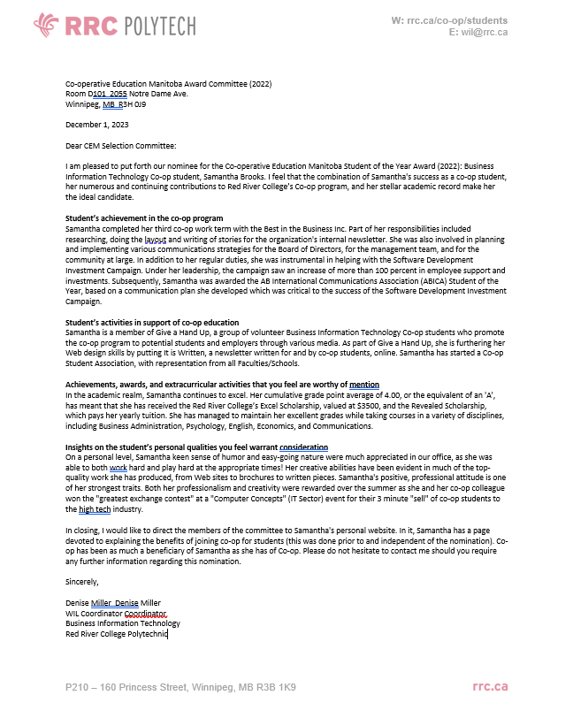
EMPLOYER REPRESENTATIVE
You are required to submit one (1) typewritten statement on company letterhead (2 pages max., 1 inch margins, 10 pt. font min.) commenting on the student’s performance in the workplace. Please cover the following points in your statement:
- The student’s duties/responsibilities;
- The student’s performance in comparison to your expectations or in comparison to other co-op students;
- Any outstanding work achievements (cost savings, process/quality improvements, design/development improvements, improved customer service, significant research or other initiatives, etc.);
- How this student, or co-op students in general have benefited your department/company.
Where possible please be specific in your examples and offer any insights you may have on the student’s work habits and character. Please include your signature at the bottom of the statement.

examplE EMPLOYER LETTER
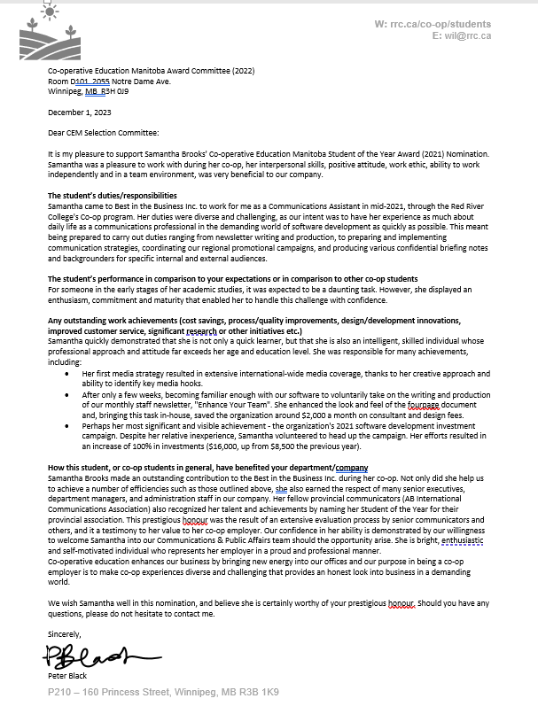
STUDENT APPLICANT
You are required to prepare and submit the following items:
- One (1) typewritten personal statement (2 pages max., 1 inch margins, 10 pt. font min.) describing how co-operative educations has enhanced your career development, personal development, and academic experience. Where possible please be specific in your examples. Your comments need not be limited to experience from the specific work term for which you are applying. Please include your signature at the bottom of the statement.
- A copy of your current resume. Co-op work term(s)/experience(s) should be clearly identified, and notes with work term dates. Extracurricular and community activities, scholarships and awards, etc. should also be noted. Do not include copies of award certificates or reference letters.
- A portfolio (max 2 pages) is recommended. You may include any times you feel will give the selection committee a better idea of who you are as a person. You may submit photocopies of newspaper and magazine articles, previous employer evaluations, letters of recommendation, published work. Awards and citations are to be listed on your resume. Any additional letters/essays/letter similar to those already requested from the institution, employer, and you in the nomination package are not acceptable.

example student statement
