Kurzweil 3000, LEARN, & Chrome or Firefox Extensions

Setting up Kurzweil 3000 Extensions

Step 1 – Download the Kurzweil 3000 Chrome or Firefox Extension
See the following for more information on how to download these extensions

Note: It is recommended that you use the Firefox extension, rather than the Chrome extension, as Firefox appears to work better with LEARN, particularly for online tests.

Note: The extension that you download must match the browser that you access LEARN through (i.e. if you download the Chrome Extension, you must access LEARN through Chrome).

Step 2 – Open the extension by clicking on the small Kurzweil 3000 icon in the top right corner
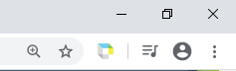

Step 3 – Enter your username and password into the pop-up window
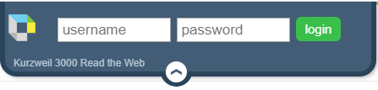
Note: if you do not know your username or password, please contact lwalkow@rrc.ca

Step 4 – Adjust Settings
- Click on the settings button
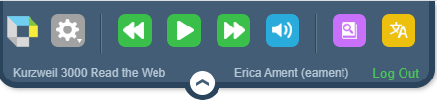
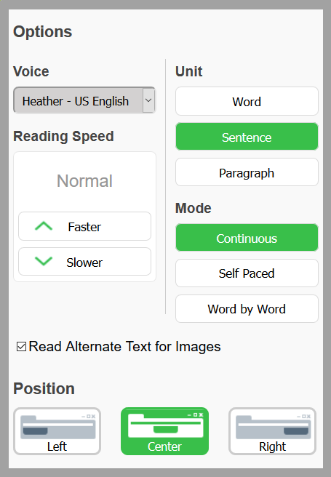
- The image to the right shows the recommended settings:
  - Voice: allows you to change to speaking voice
  - Reading speed: allows you to control how fast or how slow text is read
  - Read alternate text for images: will read aloud any alternative text entered for images
  - Position: is the position where the Kurzweil 3000 pop-up window sits. Through testing we’ve found the right position to be the least obstructive, but you may need to move it around depending on each situation.
  - Unit: is how much text does Kurzweil read at a time
  - Mode: is how is Kurzweil told what text to read. “Continuous” is recommended as it has a more natural flow, and will continue reading until the user stops it. This options allows for entire questions and possible answers to be read all together, rather than the user having to select each line to be read. In order to stop Kurzweil from reading, you can either press the pause button, or simply hit enter on your keyboard. To resume reading, press play or hit enter.
Note: with the “self-paced” mode, students will need to click to what they’d like read, and hit the play button. Once the reader has reached the end of the sentence it will automatically stop.

Video Demo of Kurzweil Reading an Exam in LEARN
Double click on the above file to see a demo on the Continuous and Self-Paced modes of Kurzweil 3000.

Navigating LEARN

Step 1 – Navigate to the LEARN site
Remember to use the same browser as the extension you downloaded!

Step 2 – Login to LEARN using your college username and password

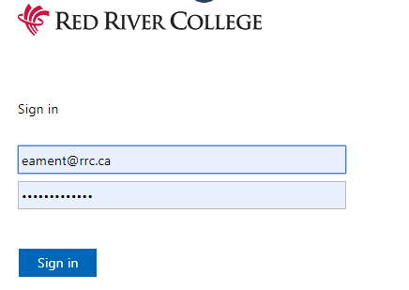

Step 3 – locate your course
Click on this link for more information on navigating LEARN and finding your course

Step 4 – locate your exam
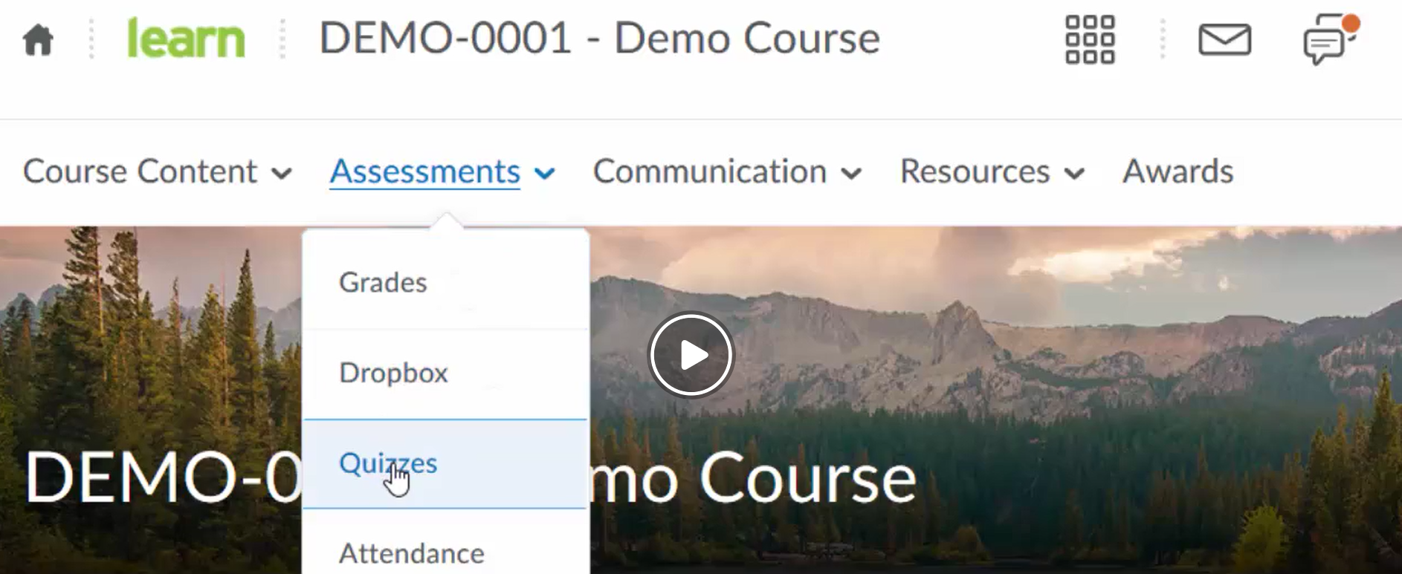

Using Kurzweil 3000 to Read LEARN Exams

Use Firefox when completing a test in LEARN, as the Chrome web extension appears to have a bug.

Once you’ve successfully logged onto the LEARN site, opened up your exam, and have logged into your Kurzweil 3000 extension, you’re ready to begin your exam!

Step 1 –
You can use Kurzweil to read you the details and any instructions that have been identified for that particular exam.
Note: the green curser indicates where Kurzweil will begin reading

Step 2 –
Once you’ve read all of the details and instructions, click on start quiz
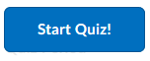

Step 3 – use your mouse curser to tell Kurzweil where you’d like to begin reading
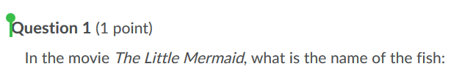
and press play
Remember, continuous mode is recommended, but you will need to stop and restart Kurzweil as you are going through your exam. This can be done with the enter button on your keyboard, or by pressing, pause/play in the Kurzweil window.
You can also have Kurzweil re-read questions to you. This can be done by moving your mouse cursor to tell Kurzweil what you’d like re-read, or you can use the back and forward buttons in the Kurzweil window.

LockDown Browser
The lockdown browser and Kurzweil 3000, even the Chrome or Firefox extensions, cannot be run at the same time – meaning if your exam requires the lockdown browser, you will not be able to use Kurzweil to read your exam to you.
If you see any of the below images, this means that your exam is set up to require use of the lockdown browser. In this case you need to contact your instructor and cc in examaccommodationsNDC@rrc.ca (for NDC students) or examaccommodationsEDC@rrc.ca (for EDC students) before you begin your exam.
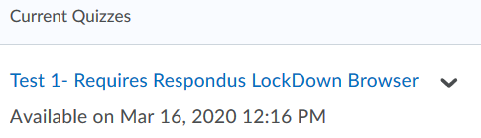
OR
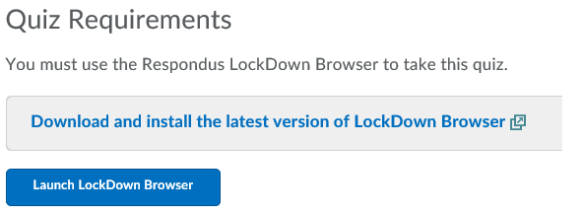

References/Helpful Links
- LEARN login issues/password reset
- LEARN How-to Videos for Students
- LEARN Quizzes
- LEARN Drop Box Assignments

